SEVEN OAKS ELEMENTARY SCHOOL KINDERGARTEN SCHOOL SUPPLY LIST
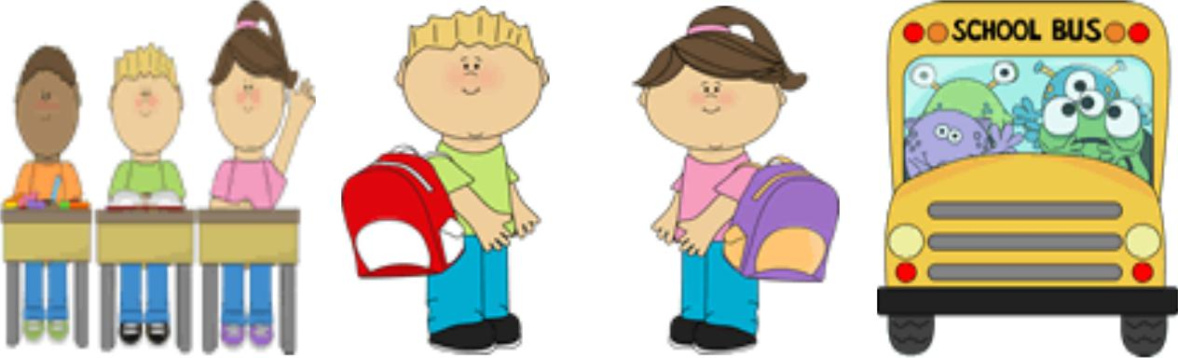

ALL SUPPLIES ARE SHARED. PLEASE DO NOT LABEL ANY SUPPLIES

12 No. 2 Pencils
1 Plastic 12inch Ruler

4 Crayola Crayons 24 ct
1 Crayola Classic Thick Markers 10 ct
1 MEAD Primary K-2 Journal (writing lines on bottom, drawing space on top)
1 CLEAR plastic pencil pouch with holes (for binder)
12 Small Glue Sticks

2- 1” white view vinyl binder
2 Blue pocket only folders

2 Green pocket only folders

2 Yellow pocket only folders
5” Blunt scissors

Dry erase markers 4 pack – (thick)
Dry erase markers 4 pack – BLACK ONLY (thin)
2 Plastic school boxes
Pink erasers (2 Pack)
2 Baby wipes
2 Boxes of Tissues
Ziploc Gallon Bags – 1 box
Ziploc Quart Bags - 1 box

