SEVEN OAKS ELEMENTARY SCHOOL
SECOND GRADE SCHOOL SUPPLY LIST
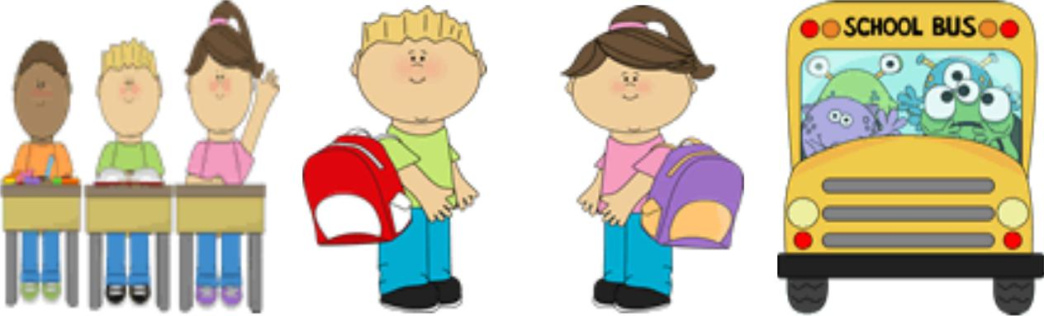

1 – 1” White vinyl clear view binder (1 required, 2 preferred)
4 - Double pocket folders WITH prongs (purple, blue, red, green)
4 - Black Marble Composition Book, wide ruled
2 - Wide Ruled 8X10.5 Filler Paper 120 Count
2 - 16 count Crayola crayons
2- Packages of #2 pencils (sharpened preferred)
12- Small Glue Sticks
2- Packages of baby wipes
1– Fiskars 5” Sharp Scissors
2 -Fluorescent Yellow Highlighters
1- Plastic sturdy pencil box
1- Box of Ziploc bags sandwich (Girls)
1- Box of Ziploc bag gallon (Boys)
2–100 Count Facial tissues
1-Box of band-aids
1-50 count of paper plates
1-4 pack dry erase marker

Donations:
· cotton balls
· color printer paper
· Magic Erasers

