SEVEN OAKS ELEMENTARY SCHOOL
Pre-K SCHOOL SUPPLY LIST
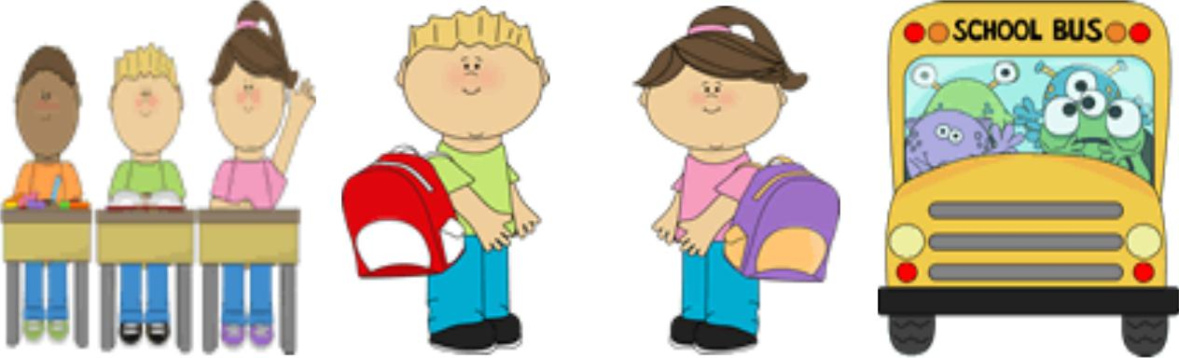

6 Small Colored Washable Glue Sticks
2 Crayola Washable Watercolors 8ct
Baby wipes
2 Boxes of Facial Tissues
Four Color Pack of Play-Doh
2 Packs of Fun Stickers
2 Crayola Small Crayons 8ct
2 Crayola Classic Thick Washable Markers 10ct
Paper Plates
Brown Paper bags
Cotton balls
Ziplock Gallon Bags (20ct)
Ziplock Quart Bags (25ct)
Elmers 4 oz. School Glue
Pack of Round Color-Coding Dot Stickers
Dry Erase Markers 4-pack
1” White Hardback Vinyl Binder(w/Clear Front Cover)
Pack of Bubbles
Bag of White Rice
Bag of Dry Beans
Box of Noodles (Elbow, Penne, Farfalle, etc.)
Box or Bag of Classroom Snack (Goldfish, Ritz Crackers, Graham Crackers)
Backpack (NO toddler sized backpacks or backpacks with wheels)
2 Complete Changes of Clothing (shorts, top, underwear, socks and shoes in a ziplock bag)
1 Crib Sheet and Small Blanket for Rest Time
Nap Mat

